

**CSE251: Electronic Circuit**

**Section: 01**

**Project Report**

**Submitted to:**

Dr. MD. Sawkat Ali

Assistant Professor

Department of Computer Science and Engineering

East West University

**Submitted by:**

Banalata Sarker (2019-1-60-004)

Sanjida Alam Tusi (2019-1-60-045)

MD. Jannatul Haq (2018-1-60-224)

**Submission Date:**

22 May 2021

**Title: Half-Wave Diode Rectifier Circuit.**

**Theory:**

The process of AC voltage signal to DC voltage is known rectification, and the circuit which is used for the rectification is known as the rectifier. The rectifier circuit can rectify both positive and negative half-cycles (full-wave rectifier) or only the positive half-cycle (half-wave rectifier) of a sine wave. A capacitor connected across the load resistor acts as a filter and reduces the ripple of the output voltage. The time constant of the RC network should be much larger than the period of the AC source voltage for effective filtering.

**Instrument:**

As we don’t have access to the university’s lab at this moment due to Corona pandemic. So, we did this experiment using PSpice Schematic.

PSpice is a circuit analysis tool that allows the user to simulate a circuit and extract key voltages and currents. It is typically taking a netlist generated from OrCAD Capture, but can also be operated from MATLAB. PSpice let us simulate and analyze our analog and mixed-signal circuits within OrCAD.

**Circuit Diagram:**

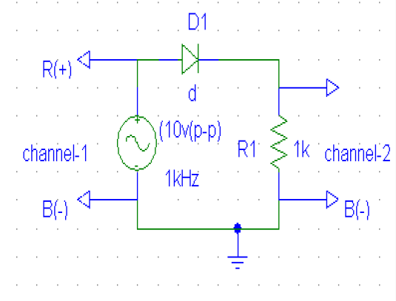

Figure no: (01)

This figure is the set up for a half-wave diode rectifier circuit.

**PSpice Simulation:**

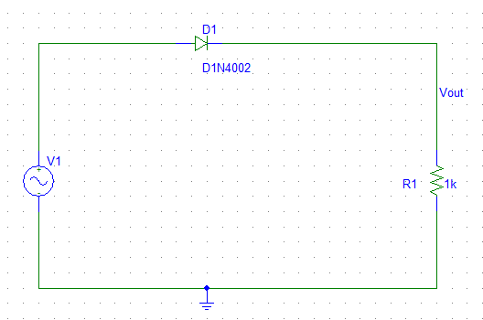

Figure no: (02)

Here we used $V_{sin}$ which is used for to get sinusoidal wave. Sinusoidal wave form allows one half cycle of an (AC voltage) to pass and block the other half on the DC side. Here we used inside the $V_{sin}$:



If we simulate this circuit, we can see this output:

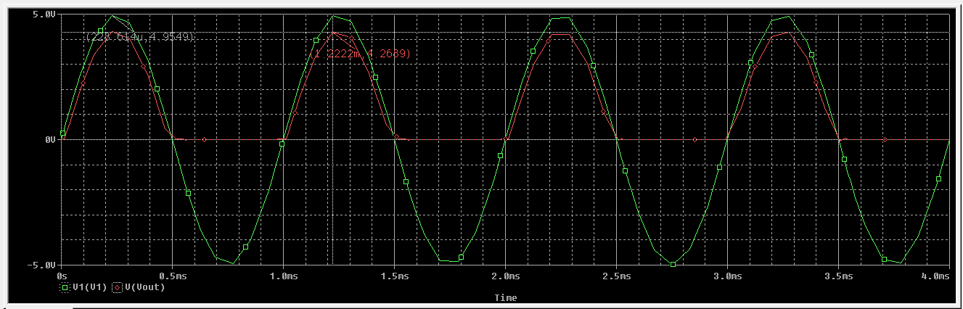

Here,

Amplitude of input $V_{in}$ = 4.9549V

Amplitude of output $V_{out}$ = 4.2689V

Difference between peak values $∆V$ = (4.9549 – 4.2689) V

= 0.686V

If we add a capacitor in this circuit the circuit will be:

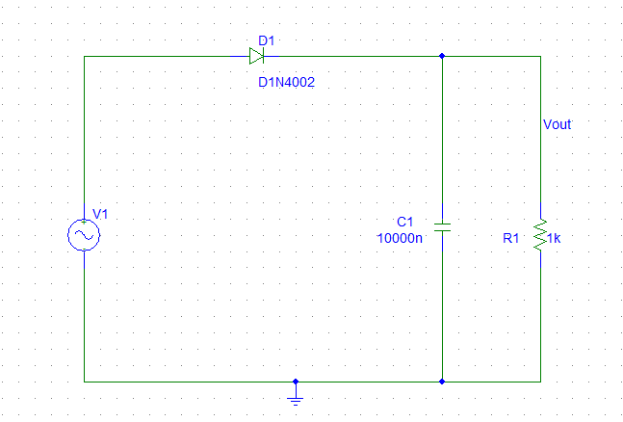

Figure no: (03)

Here, first the circuit was forward but after the connection of the capacitor the circuit become open. Then the circuit get only connection of capacitor from which the voltage and current pass. Capacitor will supply it’s charge to get the resistor until the circuit become reverse bias. The more we optimize the value of capacitor the output become more DC. But the value will not become 0, and after that capacitor will discharge. In here capacitor works like a source in negative half cycle it will discharge.

We used inside the $v_{sin}$ for get 6V in output:

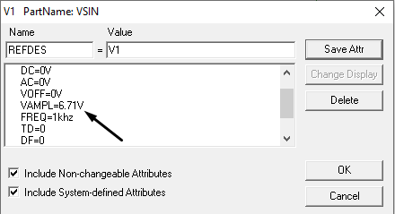

We use VAMPL = 6.71V to get exact 6V output in DC.

If we simulate this circuit, we can see this output:

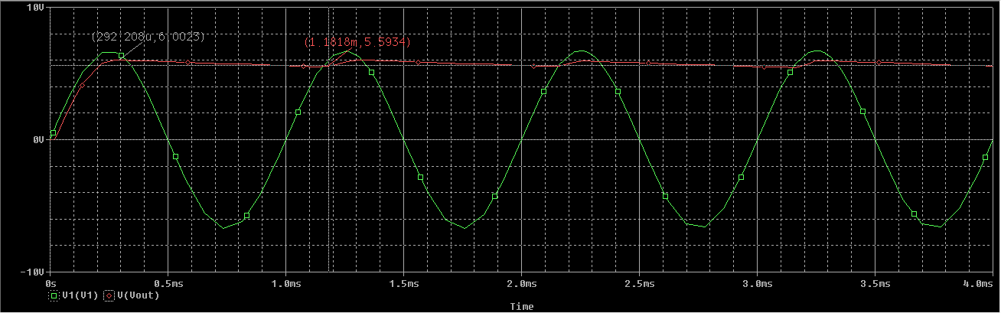

Here we can that the upper peak value = 6.0023 V

And the lower peak value = 5.5934 V

So, the difference between upper and lower value = (6.0023 – 5.5934) V

= 0.4089 V

**Half Wave Rectifier Application:**

Half wave rectifier circuits are cheaper, so they are used in some insensitive device which csn withstand the voltage variations. The output average voltage of half wave rectifier is less than the input voltage so they perform two work, step down of voltage and rectification. Some important uses of half wave rectifier are given below:

1. Half wave rectifier used in low power simple battery charger circuit.
2. Half wave rectifier is used in pulse generator circuits.
3. Half wave rectifier is used in signal demodulation circuit.
4. In soldering iron circuit half wave rectifier used.
5. Half wave rectifier used in Amplitude Modulation (AM) radio circuits as a detector.
6. It also used for the purpose of the voltage multiplier.

**Discussion and Conclusion:**

From this project, we know how to build a half wave rectifier circuit. For building we must choose a diode that can safely withstand the current the circuit will have to provide, and also the reverse bias voltage that will be applied to it. The half-wave rectifier is used most often in low-power applications because of their major disadvantages being. The output amplitude is less than the input amplitude, there is no output during the negative half cycle so half the power is wasted and the output is pulsed DC resulting in excessive ripple. By performing this experiment, we know all this stuff.

**References:**

1. Microelectronic circuit by Adel S. Sedra and Kenneth C. smith 5th edition (Oxford University Press, 198 Madison Avenue, New York, New York 10016 www.oup.com)
2. Electronic Devices and Circuit, Robert Boylestad-Louis-Nashelsky- 7th , pp. 45-46, 329-330.
3. <http://en.wikipedia.org/wiki/Rectifier>
4. <http://www.visionics.a.se/html/curriculum/Experiments/HW%20Rectifier/Half%20Wave%20Rectifier1.html>
5. <http://www.circuitstoday.com/half-wave-rectifiers>
6. Howard V. Malmstadt, Christie G. Enke and Stanley R. Crouch. Electronics and Instrumentation for Scientists (Menlo Park, California: The Benjamin/Cummings Publishing Company, Inc., 1981), pp.57-58, 61-62.